**MOKO Beacon Advertising Data Format**

Contents

1. Generic 3

1.1 Raw Data 3

1.2 Standard Apple iBeacon 4

1.3 Standard Google Eddystone-UID 4

1.4 Standard Google Eddystone-URL 5

1.5 Standard Google Eddystone-TLM (Unencrypted) 6

2. Moko Standard Firmware Adv Format 7

2.1 MkiBeacon Firmware 7

2.1.1 Response packet 7

2.1.2 MkiBeacon - 3-axis Acc sensor data (Response packet) 7

2.2 BeaconX Firmware 8

2.2.1 BeaconX - Device Info 8

2.2.2 BeaconX - iBeacon 8

2.3 BeaconX Pro (BXP) series Firmware 9

2.3.1 BeaconX Pro - Device Info 9

2.3.2 BeaconX Pro - iBeacon (Response packet) 10

2.3.3 BeaconX Pro - 3-axis Acc sensor data 10

2.3.4 BeaconX Pro - T&H sensor data 13

3.Appendix 15

3.1 Tx Power Chart 15

Version record 16

# 1. Generic

## 1.1 Raw Data

No format filtering， all BLE advertising data.

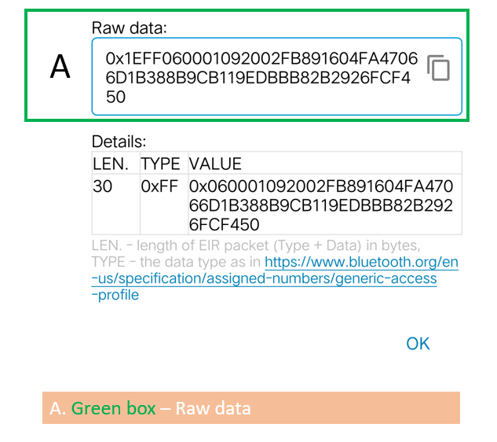

## 1.2 Standard Apple iBeacon

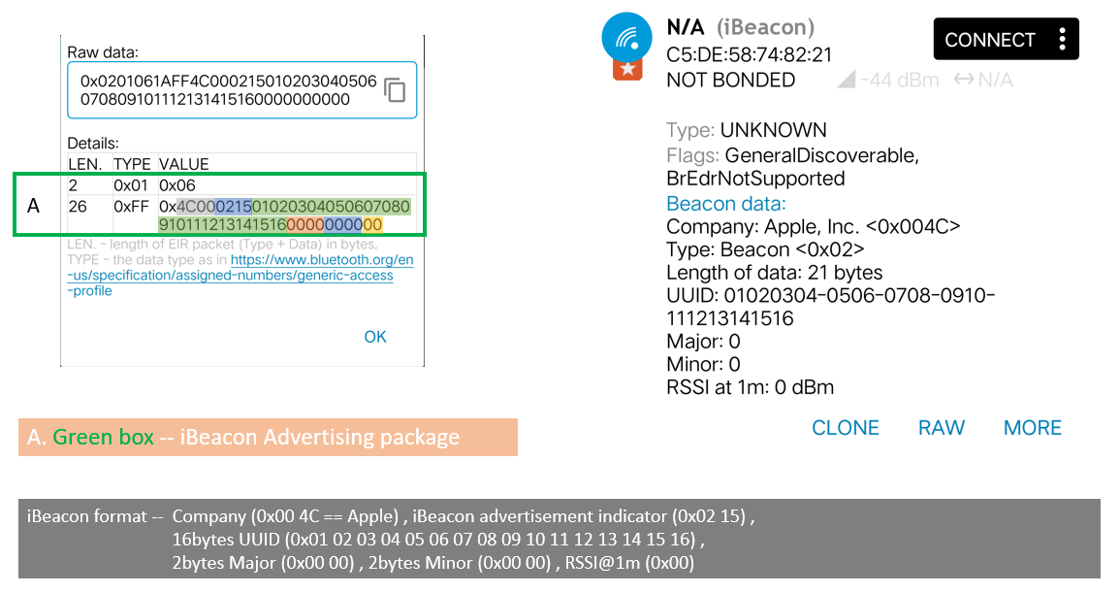

## 1.3 Standard Google Eddystone-UID

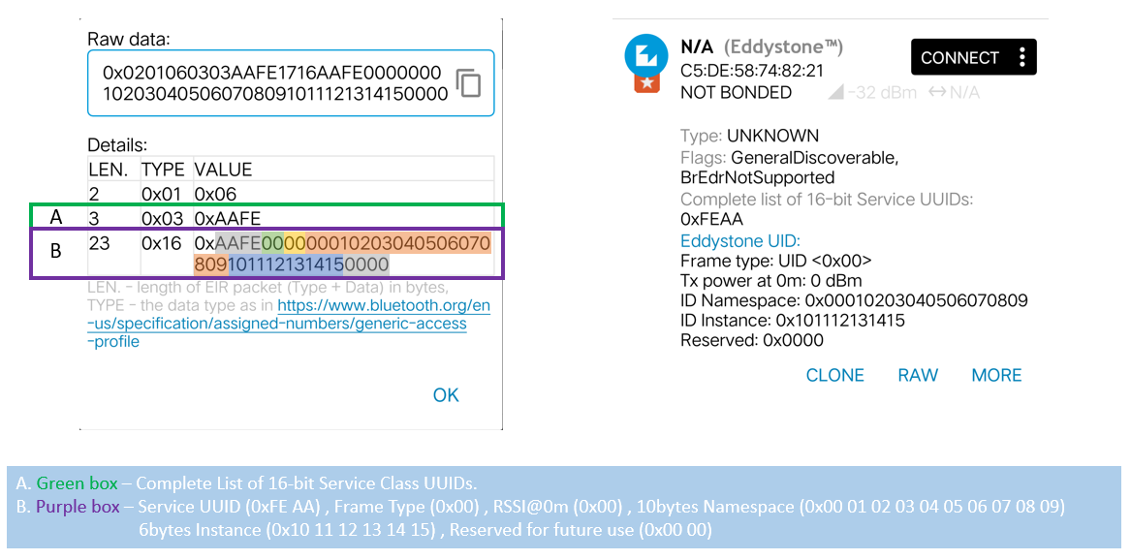

## 1.4 Standard Google Eddystone-URL

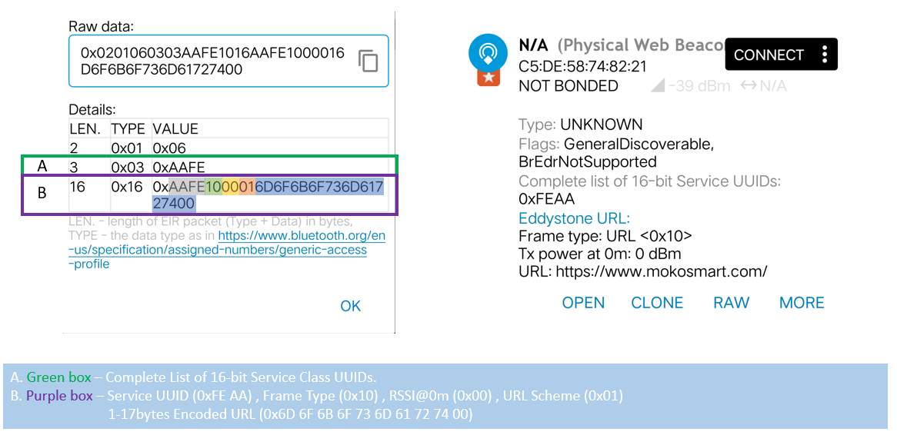

**URL Scheme Prefix chart:**

|  |  |  |
| --- | --- | --- |
| Decimal | Hex Value | Expansion |
| 0 | 0x00 | http://www. |
| 1 | 0x01 | https://www. |
| 2 | 0x02 | http:// |
| 3 | 0x03 | https:// |

**Eddystone-URL HTTP URL encoding chart:**

|  |  |  |
| --- | --- | --- |
| Decimal | Hex Value | Expansion |
| 0 | 0x00 | .com/ |
| 1 | 0x01 | .org/ |
| 2 | 0x02 | .edu/ |
| 3 | 0x03 | .net/ |
| 4 | 0x04 | .info/ |
| 5 | 0x05 | .biz/ |
| 6 | 0x06 | .gov/ |
| 7 | 0x07 | .com |
| 8 | 0x08 | .org |
| 9 | 0x09 | .edu |
| 10 | 0x0a | .net |
| 11 | 0x0b | .info |
| 12 | 0x0c | .biz |
| 13 | 0x0d | .gov |
| other | 0x0e~0x20; 0x7F~0xFF | Reserved for Future Use |

## 1.5 Standard Google Eddystone-TLM (Unencrypted)

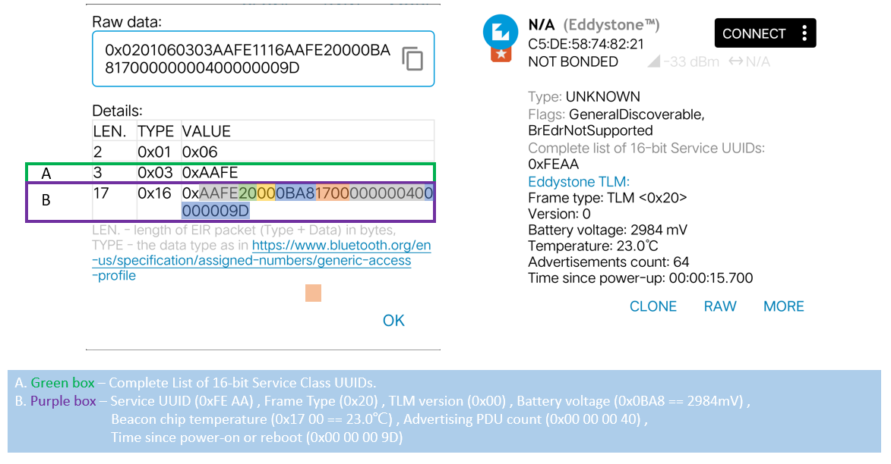

# 2. Moko Standard Firmware Adv Format

## 2.1 MkiBeacon Firmware

### 2.1.1 Response packet

MkiBeacon ADV packet = Standard Apple iBeacon advertising format + Customized response packet.

The response packet does not contain iBeacon UUID.

It is for the iOS OS to display the iBeacon data.

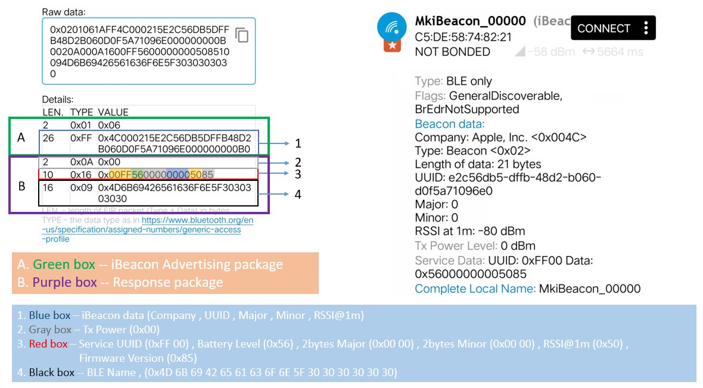

### 2.1.2 MkiBeacon - 3-axis Acc sensor data (Response packet)

MkiBeacon - 3-axis Acc sensor data = Standard Apple iBeacon advertising format + Customize response packet.

The response packet does not contain iBeacon UUID.

It is for the iOS OS to display the iBeacon data and 3-axis accelerometer sensor data.

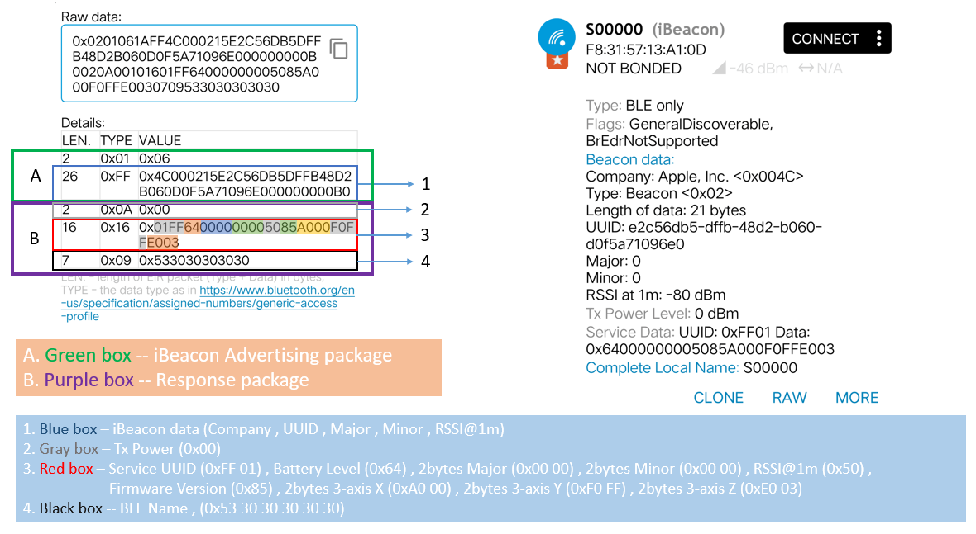

## 2.2 BeaconX Firmware

### 2.2.1 BeaconX - Device Info （Always advertise）

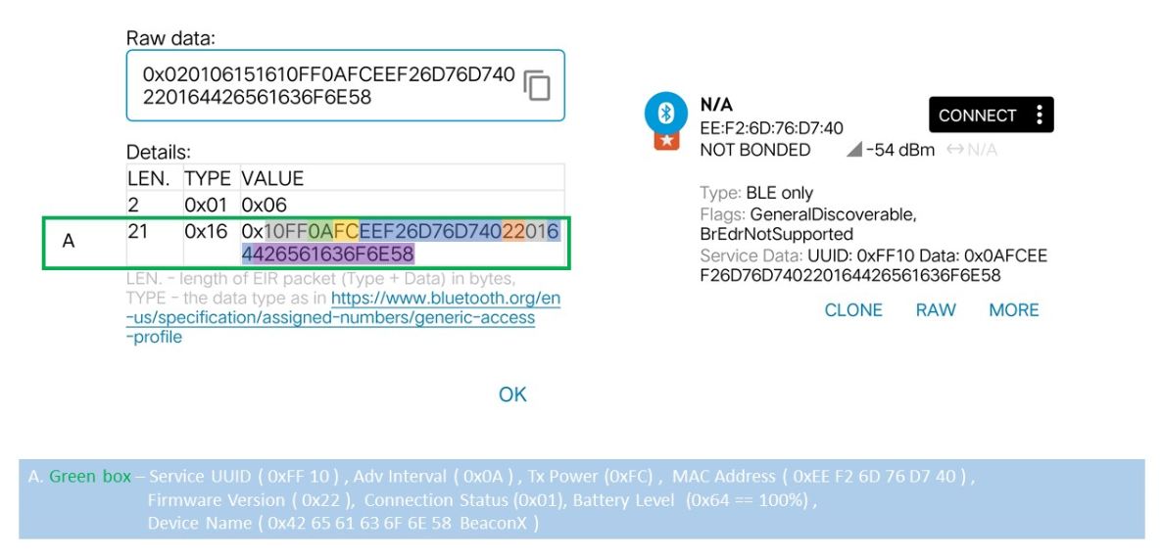

### 2.2.2 BeaconX - iBeacon

It is for the iOS OS to display the iBeacon data.

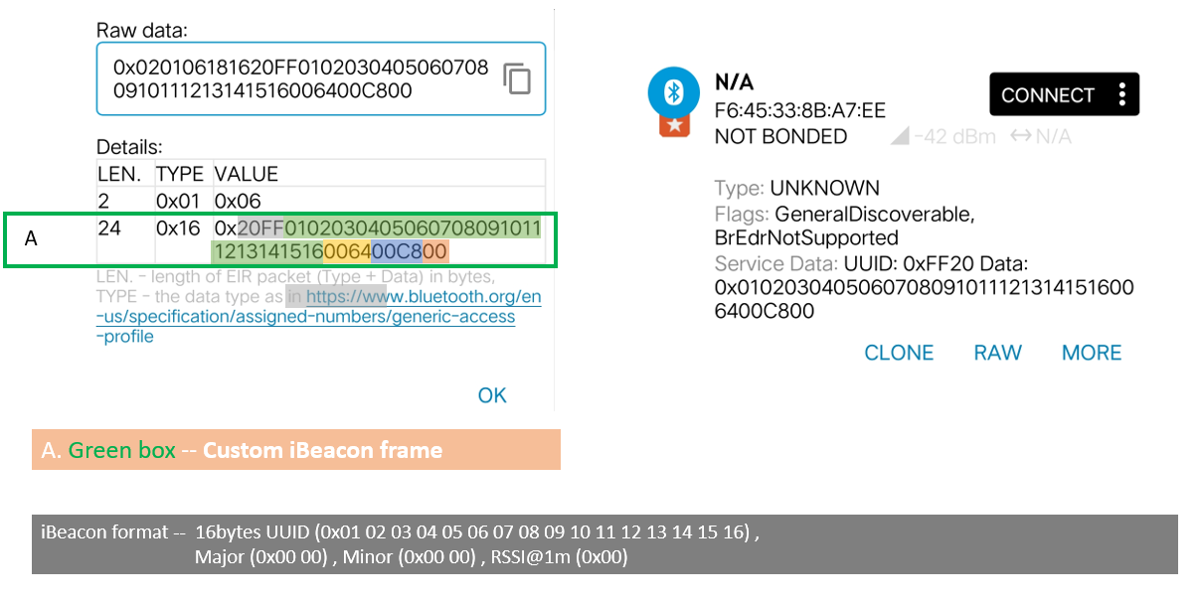

## 2.3 BeaconX Pro (BXP) series Firmware

### 2.3.1 BeaconX Pro - Device Info

### 2.3.2 BeaconX Pro - iBeacon (Response packet)

BeaconX Pro - iBeacon = Standard Apple iBeacon advertising packet + Customized response packet.

It is for the iOS OS to display the iBeacon data.

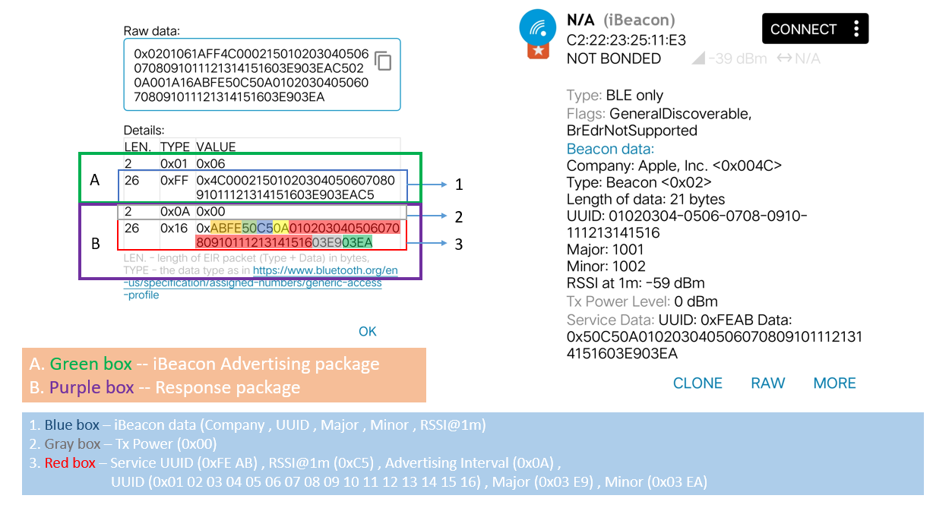

### 2.3.3 BeaconX Pro - 3-axis Acc sensor data

This format applies the old firmware version - BeaconX Pro V3.x.x series. The default 3-axis accelerometer data is 8bit, and the lower 8 bits is 0b0000 0000.

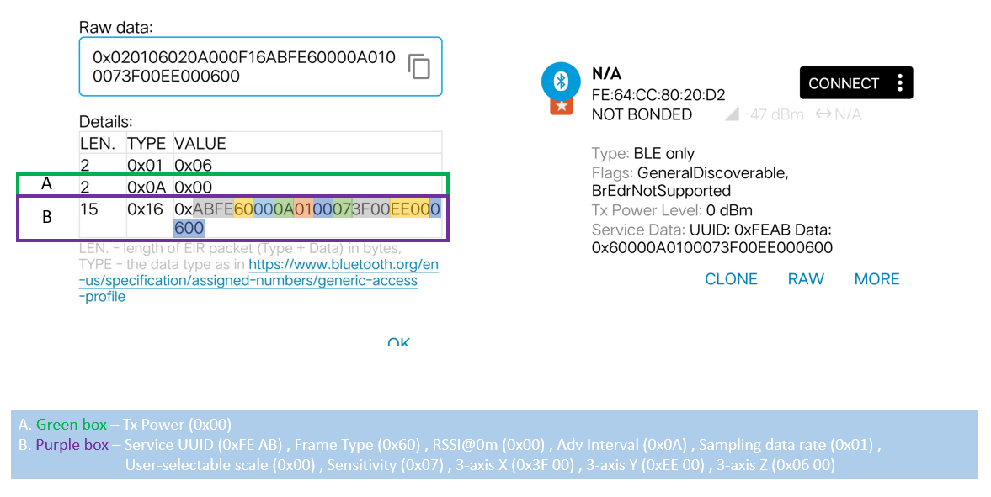

Conversion formula:

If the original data is less than 0x8000:

**Result=(RAW>>8) * s;**

If the original data is greater than or equal to 0x8000:

**Result=((RAW>>8)-0x100) * s;**

|  |  |  |
| --- | --- | --- |
| Sampling mode | Full-Scale | s |
| Low-power mode (8-bit data output) | ±2g | 16 mg/digit |
| ±4g | 32 mg/digit |
| ±8g | 64 mg/digit |
| ±16g | 192 mg/digit |

For example : Device lies in flat desk and Z-axis down to desk, and keep static status.   
Preconditions:

Sampling mode --- Low power mode

Full-Scale ---±2g

Data output : X**_RAW** =0xFF00; Y**_RAW** =0xFB00; Z**_RAW** =0xC000;

Formula:

X_result=((0xFF00>>8)-0x100)*16 mg/digit= (0xFF-0x100)*16 mg/digit=-1*16=-16mg;

Y_result=((0xFD00>>8)-0x100)*16 mg/digit= (0xFD-0x100)*16 mg/digit=-3*16=-48mg;

Z_result=((0xC000>>8)-0x100)*16 mg/digit= (0xC0-0x100)*16 mg/digit=-64*16=-1024mg;

This format applies the new firmware version - BXP，BXP-D and other BXP series firmware version. The default 3-axis accelerometer data is 12bit, and the lower 4 bits is 0b0000.

Conversion formula:

If the original data is less than **0x8000**:

**Result=(RAW>>4) * s;**

If the original data is greater than or equal to **0x8000**:

**Result=((RAW>>4)-0x1000) * s;**

|  |  |  |
| --- | --- | --- |
| Sampling mode | Full-Scale | s |
| High-resolution mode (12-bit data output) | ±2g | 1 mg/digit |
| ±4g | 2 mg/digit |
| ±8g | 4 mg/digit |
| ±16g | 12 mg/digit |

For example : Device lies in flat desk and Z-axis down to desk, and keep static status.   
Pre-condition 1:

Sampling mode --- High resolution mode

Full-Scale ---±2g

Data output : X**_RAW** =0xFE40; Y**_RAW** =0xFE00; Z**_RAW** =0xC0C0;

Formula:

X_result=((0xFE40>>4)-0x1000)*1 mg/digit= (0x0FE4-0x1000)*1 mg/digit=-28*1=-28mg;

Y_result=((0xFE00>>4)-0x1000)*1 mg/digit= (0x0FE0-0x1000)*1 mg/digit=-32*1=-32mg;

Z_result=((0xC0C0>>4)-0x1000)*1 mg/digit= (0x0C0C-0x1000)*1 mg/digit=-1012*1=-1012mg;

Pre-condition 2:

Sampling mode --- High resolution mode

Full-Scale ---±8g

Data output : X**_RAW** =0xFF80; Y**_RAW** =0xFF80; Z**_RAW** =0xF040;

Formula:

X_result=((0xFF80>>4)-0x1000)*4 mg/digit= (0x0FF8-0x1000)*4 mg/digit=-8*4=-32mg;

Y_result=((0xFF80>>4)-0x1000)*4 mg/digit= (0x0FF8-0x1000)*4 mg/digit=-8*4=-32mg;

Z_result=((0xF040>>4)-0x1000)*1 mg/digit= (0x0F04-0x1000)*4 mg/digit=-252*4=-1008mg;

**Sampling data rate chart:**

|  |  |
| --- | --- |
| Hex Value | Data Rate |
| 0x00 | 1Hz |
| 0x01 | 10Hz |
| 0x02 | 25Hz |
| 0x03 | 50Hz |
| 0x04 | 100Hz |

**User selectable scale chart:**

|  |  |
| --- | --- |
| Hex Value | Scale |
| 0x00 | ±2g |
| 0x01 | ±4g |
| 0x02 | ±8g |
| 0x03 | ±16g |

### 2.3.4 BeaconX Pro - T&H sensor data

This format applies the old firmware version - BeaconX Pro V3.x.x series.

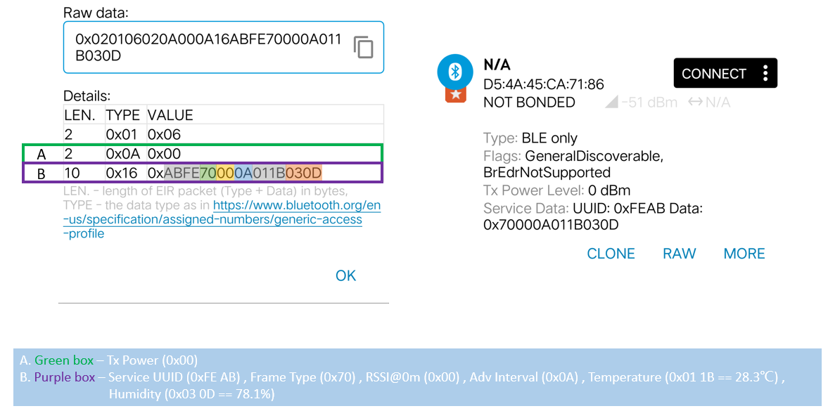

This format applies the new firmware version - BXP series firmware version.

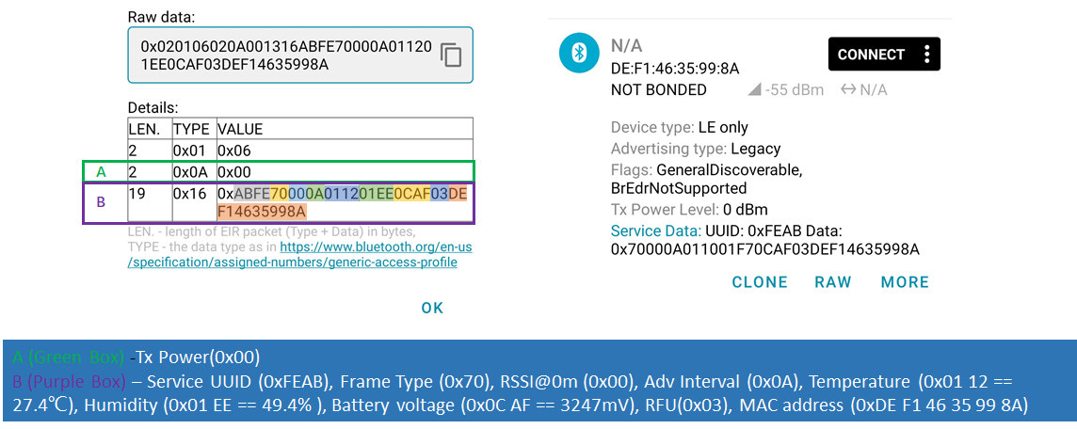

# 3.Appendix

## 3.1 Tx Power Chart

|  |  |
| --- | --- |
| Hex Value | Tx Power |
| 0x04 | +4 dBm |
| 0x03 | +3 dBm |
| 0x00 | 0 dBm |
| 0xFC | -4 dBm |
| 0xF8 | -8 dBm |
| 0xF4 | -12 dBm |
| 0xF0 | -16 dBm |
| 0xEC | -20 dBm |
| 0xD8 | -40 dBm |

# Version record

|  |  |  |  |
| --- | --- | --- | --- |
| Version | Data | Notes | Contributor |
| V1.0 | 2021.07.09 | Initial version | Daniel |
| V1.1 | 2021.12.10 | 1. Modify formula of 3-axis accelerometer data which expressed in BXP app. | Daniel |
| V1.2 | 2021.12.16 | 1. Modify advertisement format of device info advertisement and 3-axis Acc advertisement. | Daniel |